This template must be used to answer the case study.
(Please type your answers within the box underneath each question)

Student name (LAST NAME first name):
Student number:
Campus:
Tutorial session (time and room no.):
Tutor’s name:
- Rationale for giving Mary a tetanus booster (Total: 10 marks)
  - What is the organism that causes tetanus and why is it of concern in this situation?
(5 marks)
Tetanus fact sheet NSW HEALTH

  - Discuss the rationale for giving Mary the tetanus booster. (5 marks)
https://immunisationhandbook.health.gov.au
Australian immunisation handbook

- Physiological basis of the three wound observations (Total: 20 marks)
  - For each of the three wound observations indicate, and provide a rationale, as to whether it is a sign or a symptom. (2 marks)
  - Name and discuss the physiological basis of the first observation. (6 marks)
  - Name and discuss the physiological basis of the second observation. (6 marks)
  - Name and discuss the physiological basis of the third observation. (6 marks)
- Development and benefits of fever (Total:15 marks).
  - How did Mary’s fever develop? (9 marks)
  - Discuss two ways in which fever is beneficial. (6 marks)
- Possible sources of contamination and modes of transmission (Total: 20 marks)
  - Name one endogenous source of contamination and discuss the mode of transmission from the source to the new host. (10 marks)
  - Name one exogenous source of contamination and discuss the mode of transmission from the source to the new host. (10 marks)
- Appropriateness of Augmentin as the antibacterial agent prescribed to Mary (Total: 15 marks)
  - Given the colonizing organism was Staphylococcus aureus, discuss why Augmentin is an appropriate prescription? (6 marks)
  - Describe the added benefits that Augmentin provides, with reference to the role of the major ingredients in Augmentin. (9 marks)
- Presentation (Total: 20 marks)
  - Referencing in-text and in reference list conforms to APA 7th ed. referencing style.
  - Critique supported by relevant literature as prescribed.
  - Correct sentence structure, paragraph, grammatical construction, spelling, punctuation, and coherent presentation.

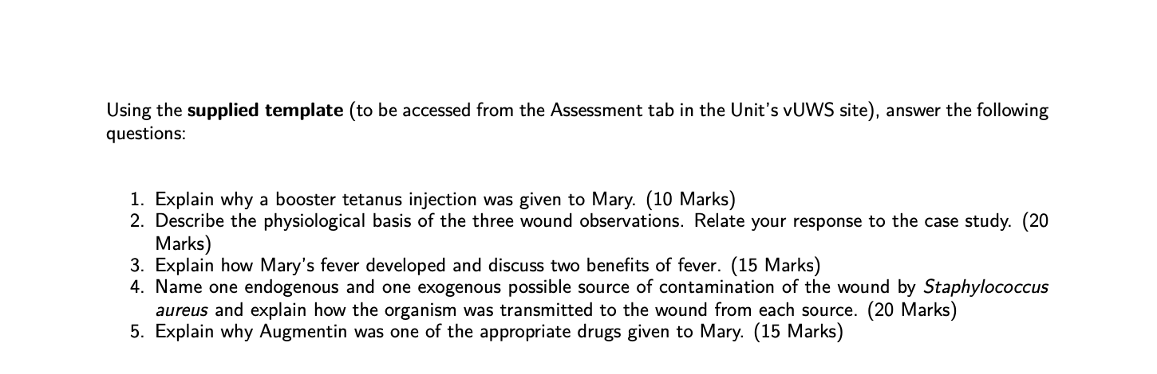
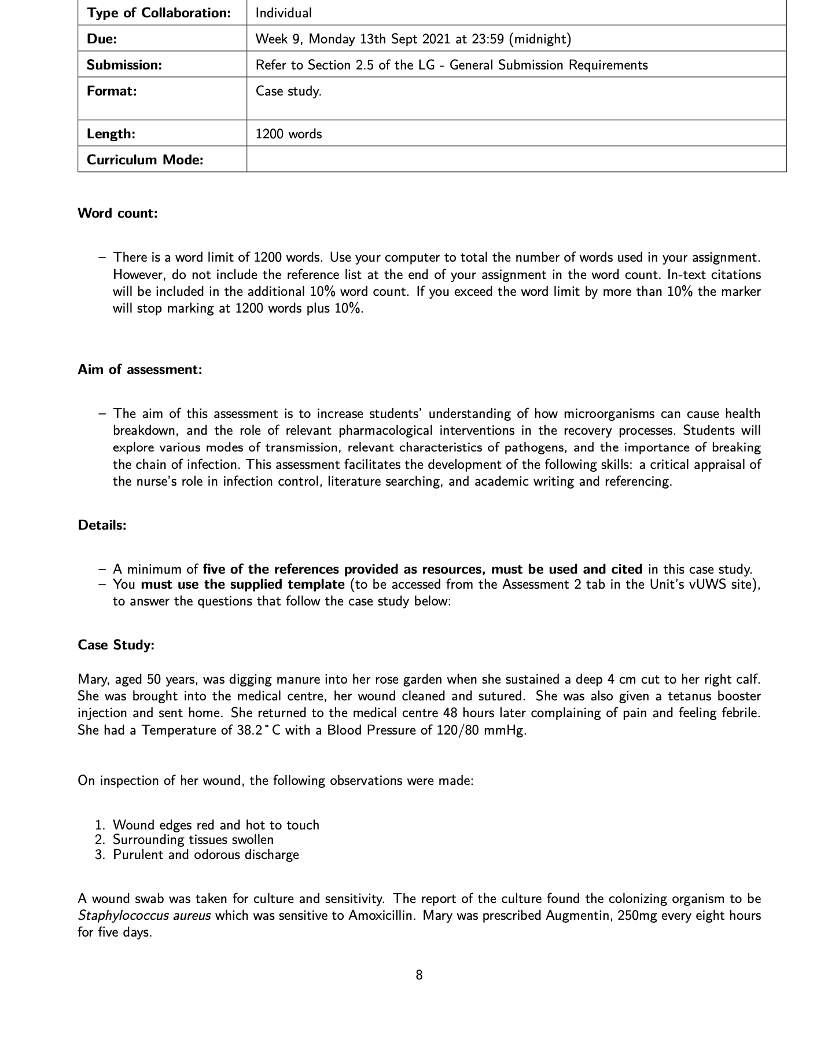
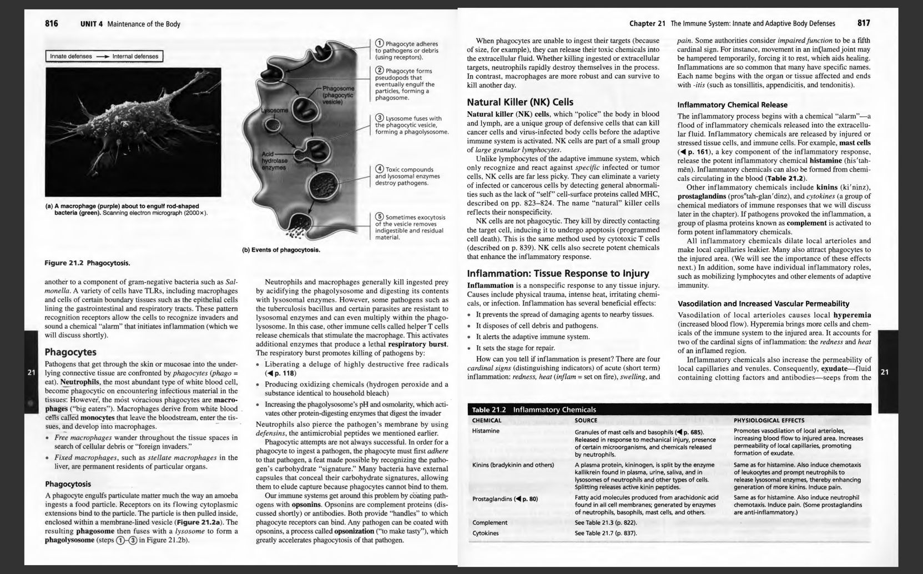
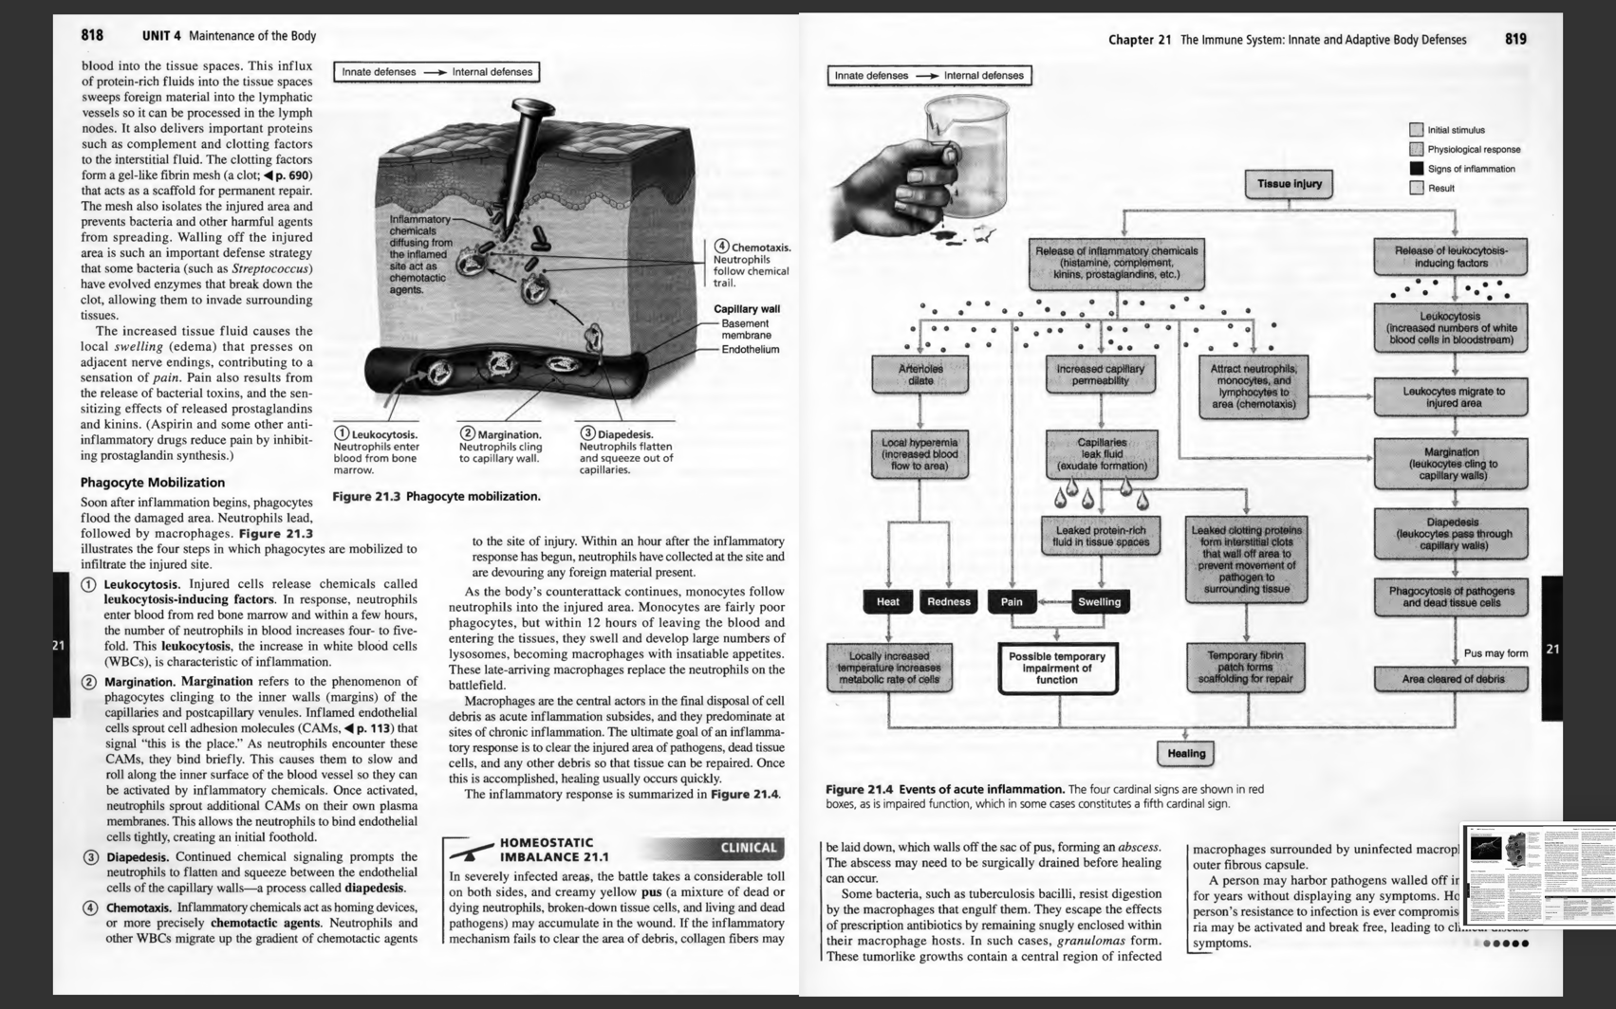
For question 2 and question 3
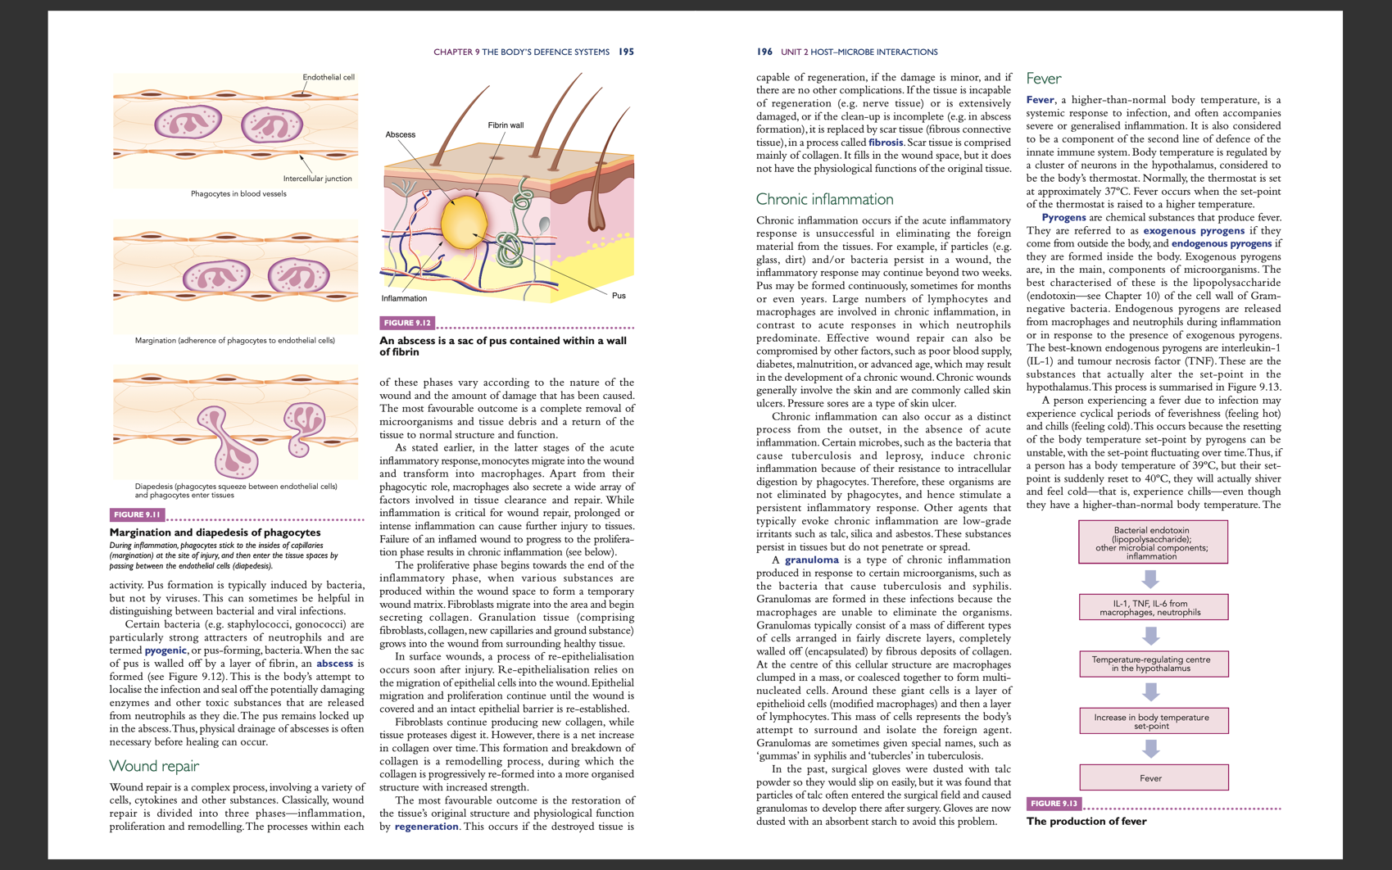
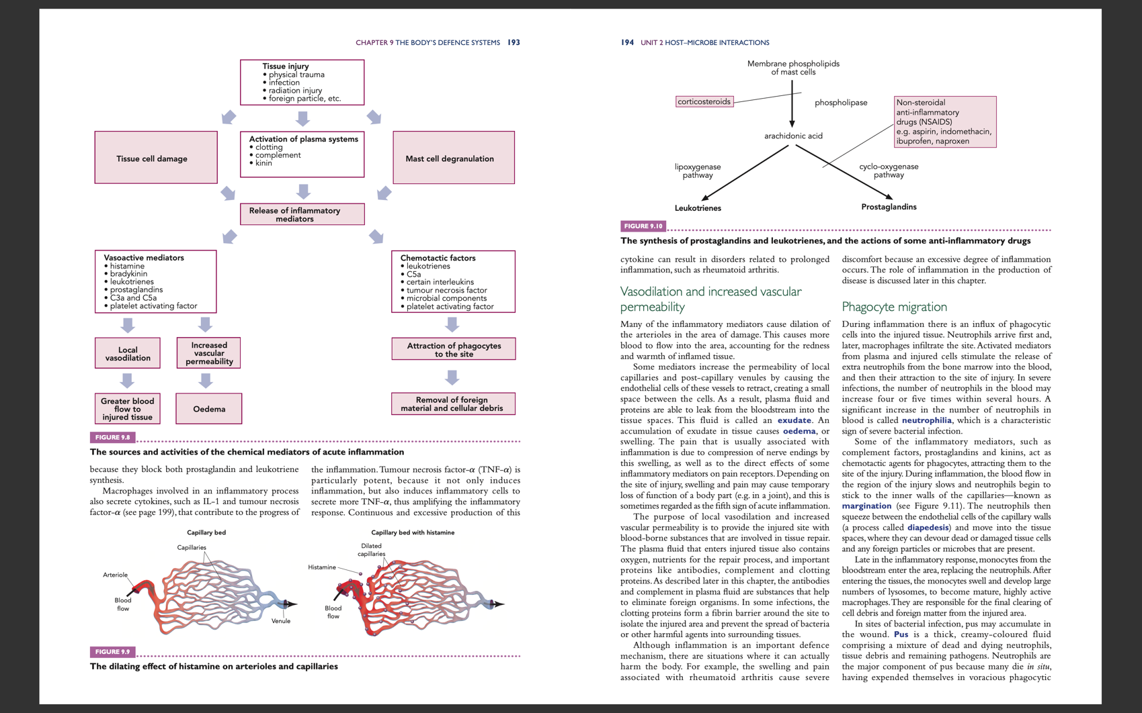
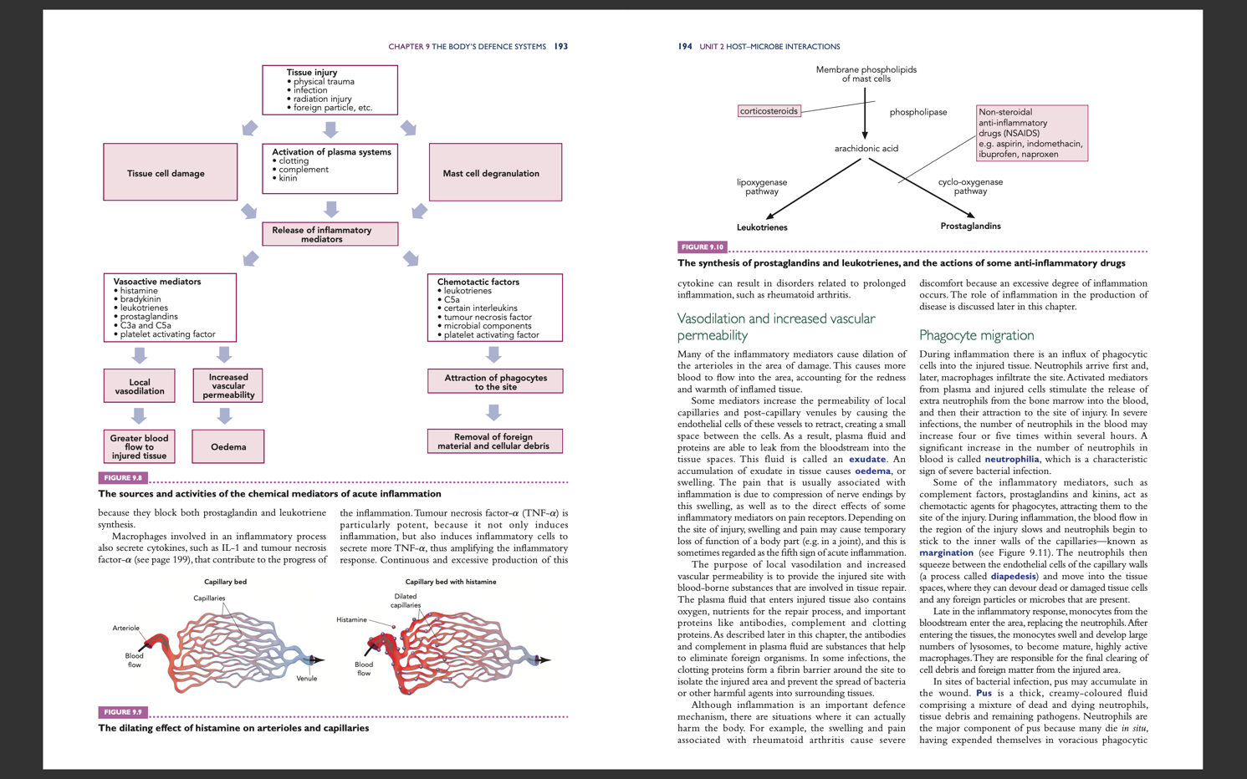
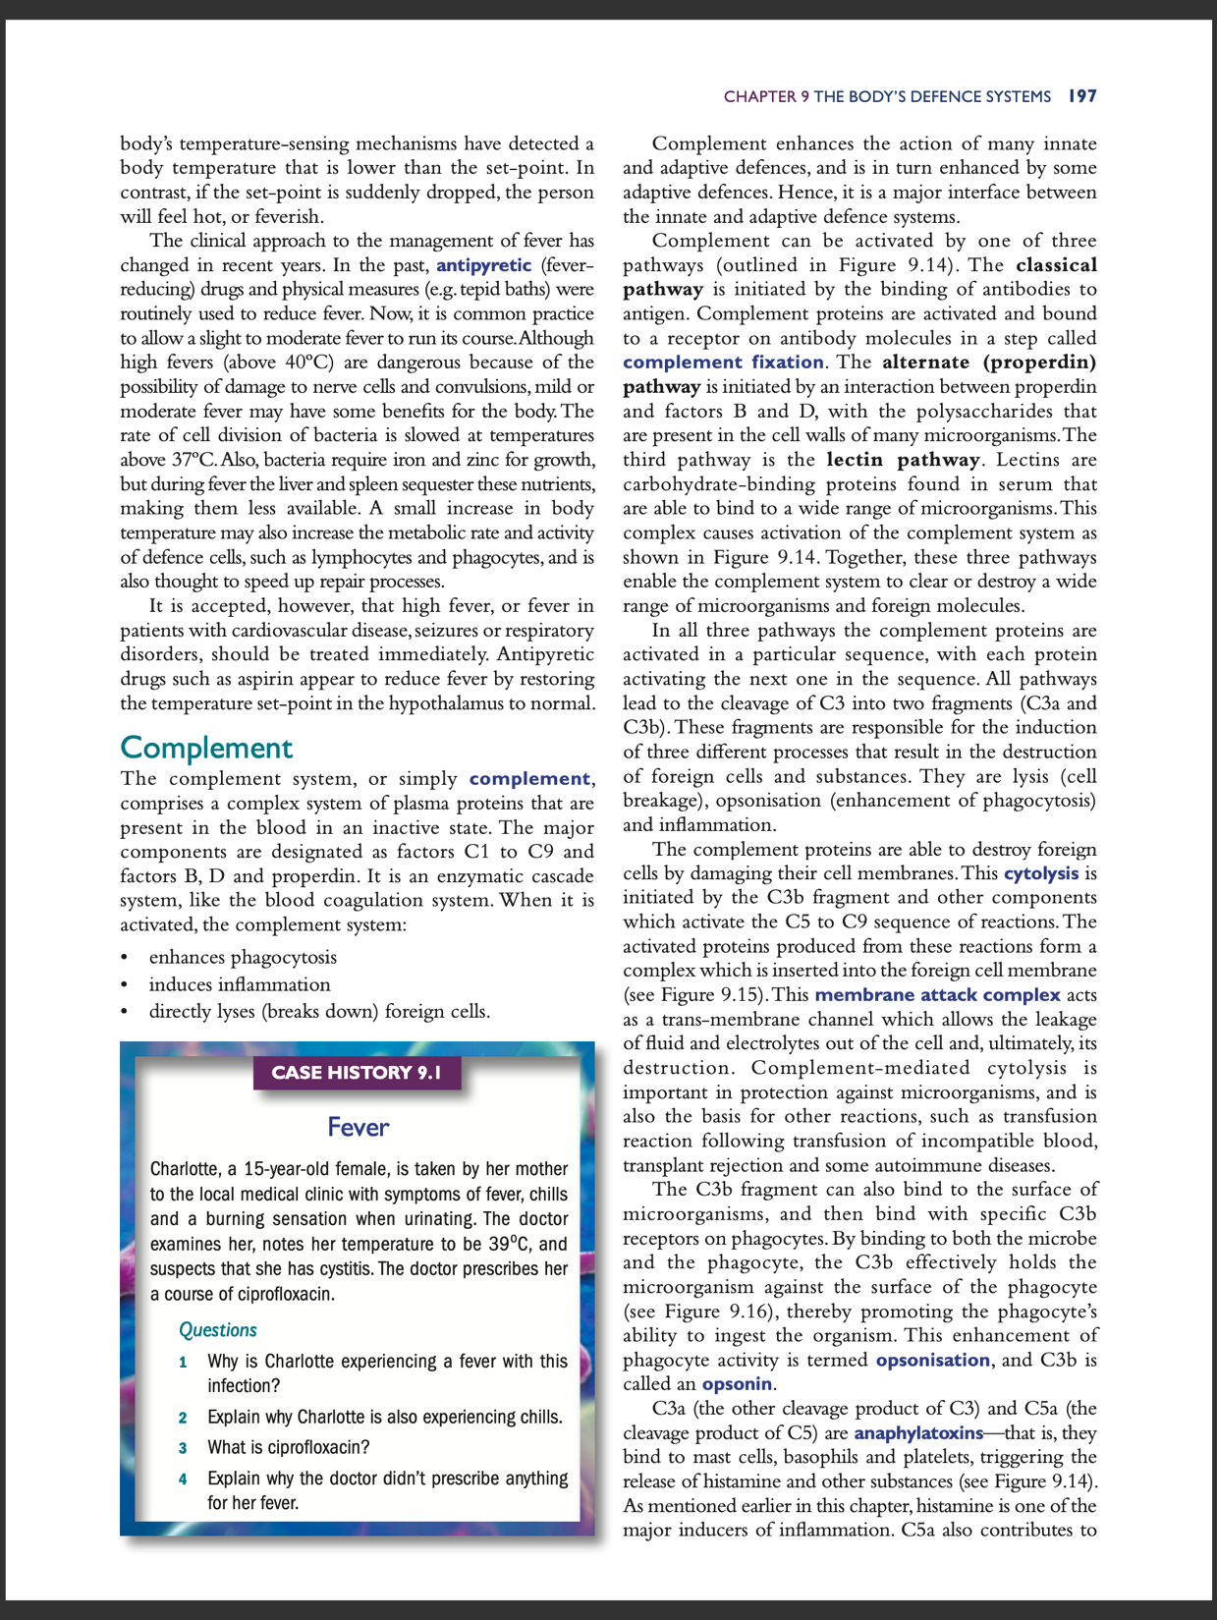

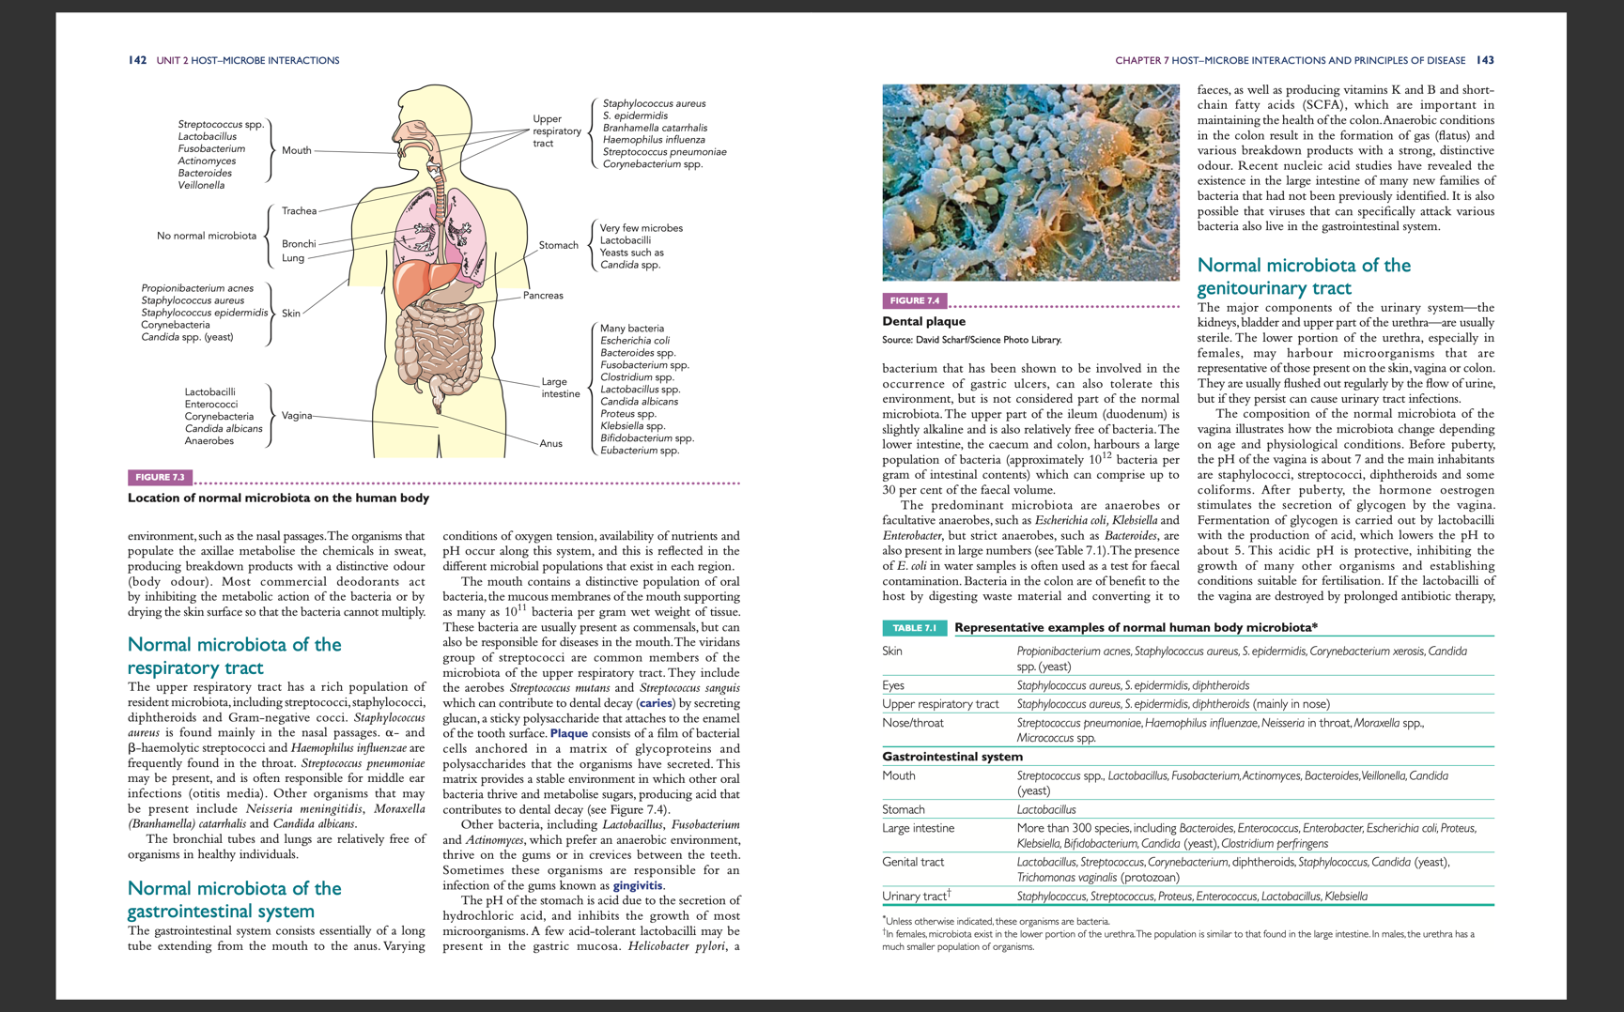
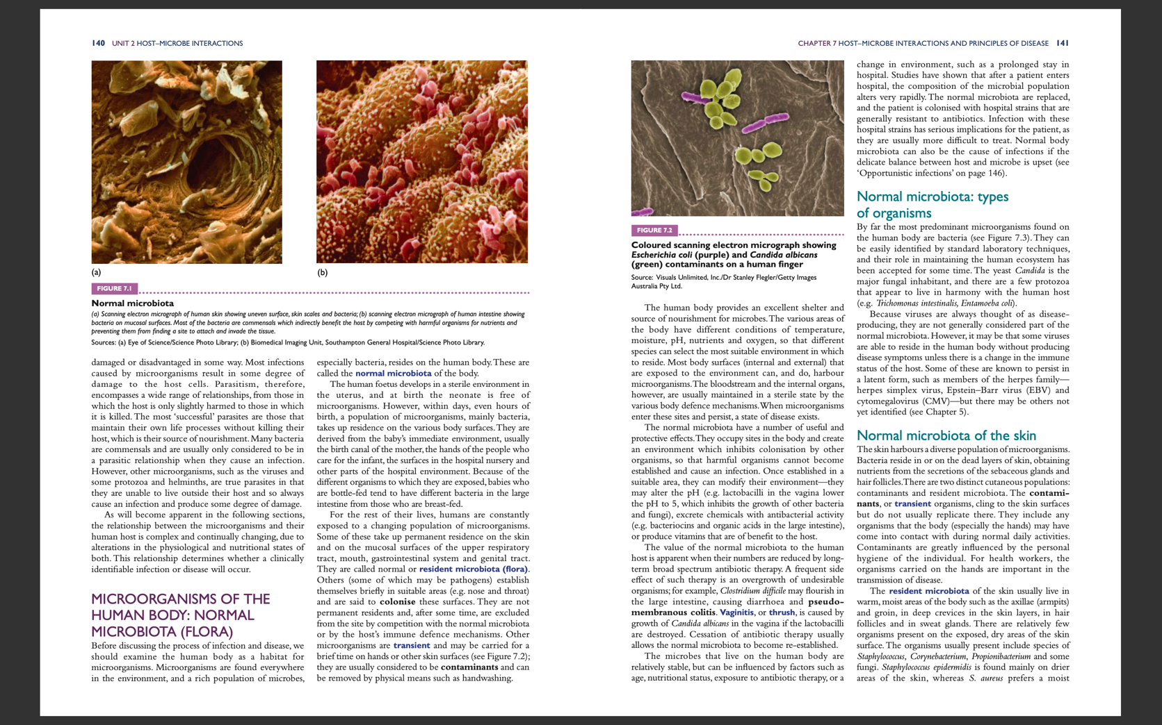
For question 4
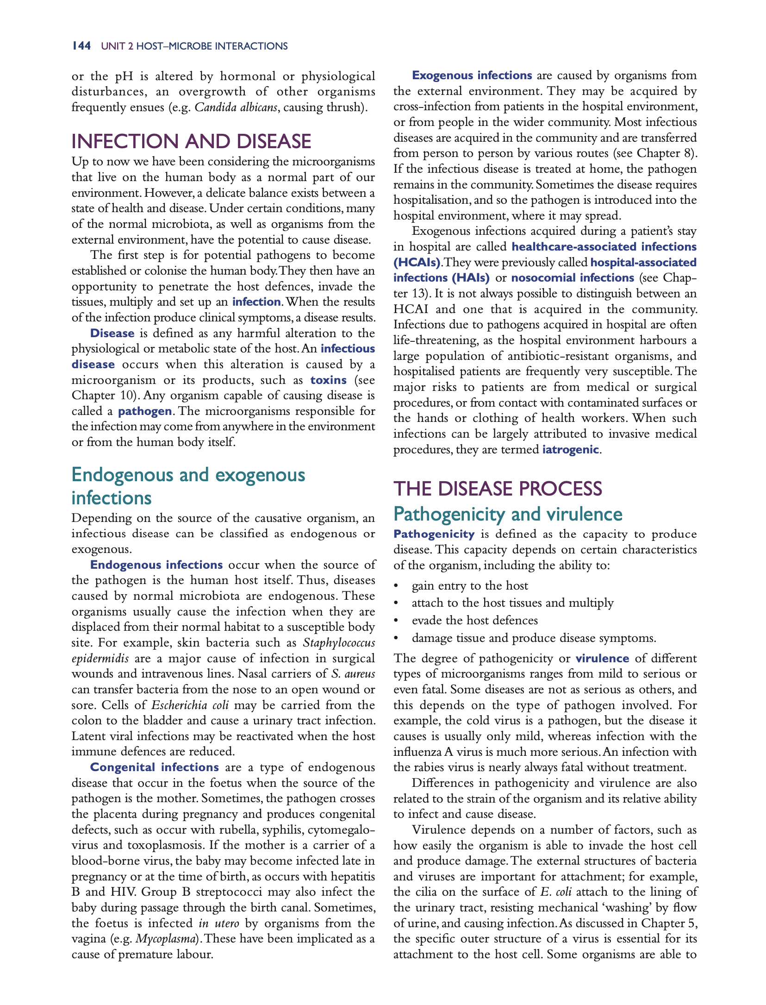

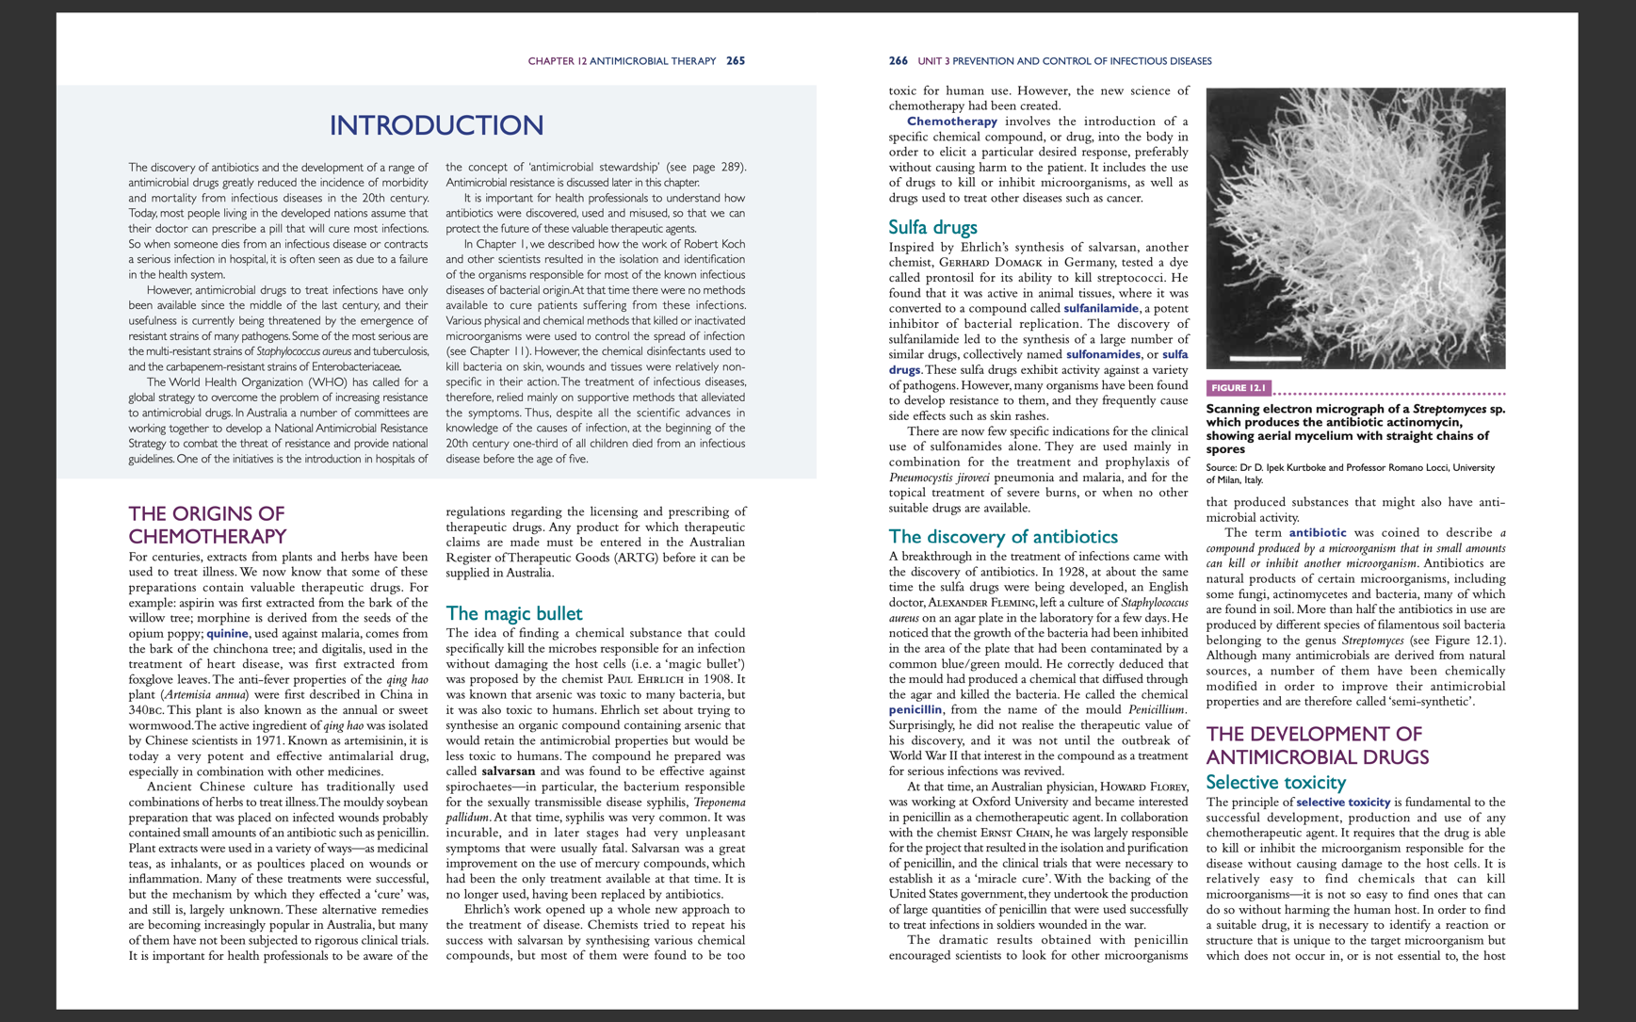
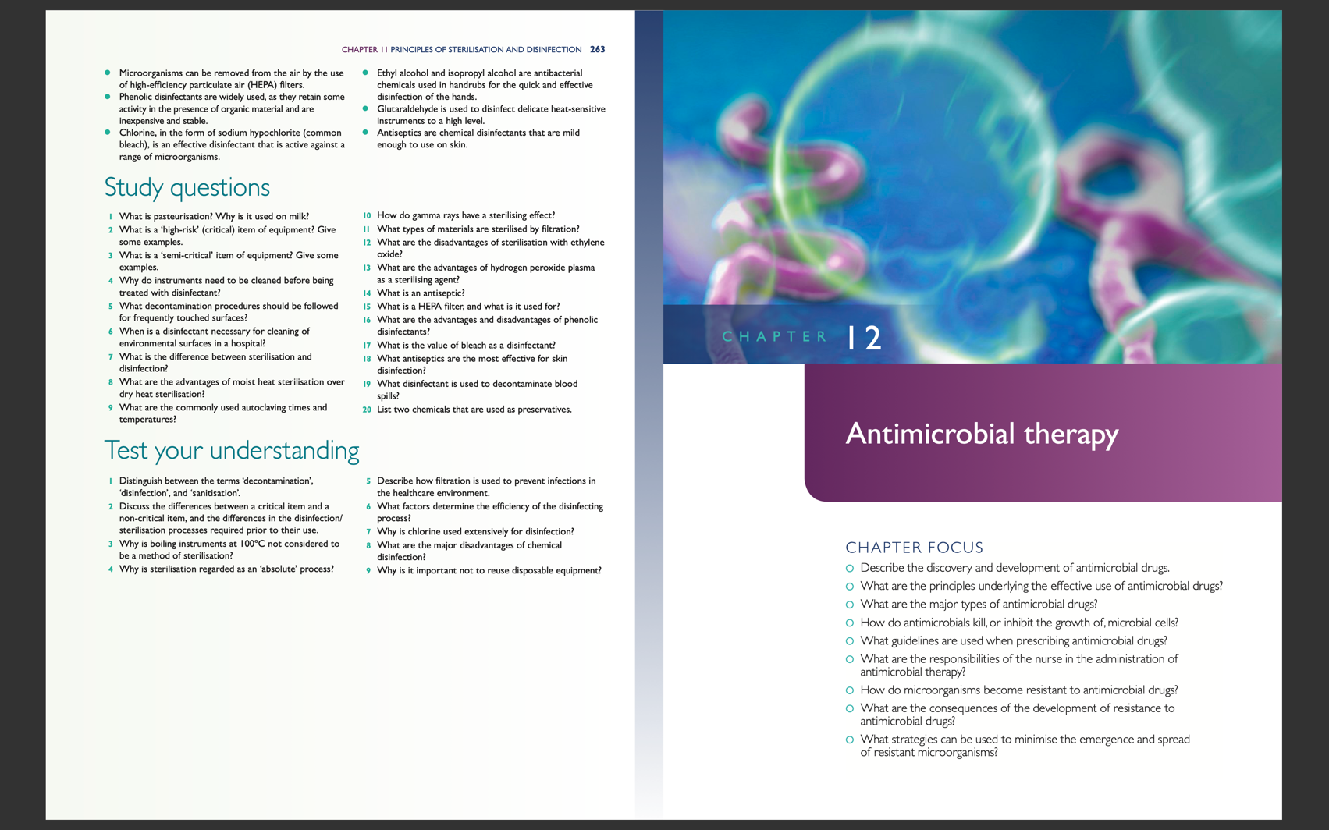
For question 5
